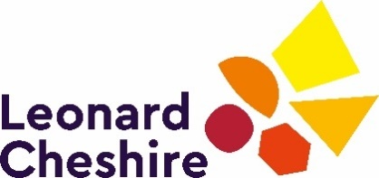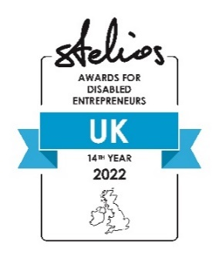

Stelios Awards for Disabled Entrepreneurs in the UK 2022
Application Form (as at 30Jan22 final)
Applications open:
from Tuesday 1 February 2022 deadline to apply not later than 20 April 2022 at 17:00
All completed applications to be emailed to tracy.ghori@stelios.com by 20/4/22.

For any help filing in the application, eligibility queries, support or if you have any accessibility requirements please contact the Stelios Award Team on steliosaward@leonardcheshire.org or call the Helpline on 07525 617 507
Applicants can also contact us via our Facebook Group:
Stelios Awards for Disabled Entrepreneurs in the UK

Applicant’s Personal Details

- First name:
- Last name:
- Date of birth:

- Do you have a disability as defined by the Equality Act 2010?
Yes/No (please delete as appropriate)

- Have you applied to the Stelios Awards before?
Yes/No (please delete as appropriate)

- If yes, please list the years you have applied and the name of the business(es):

Click or tap here to enter text.

Applicant’s Business Details

- In one sentence please explain what your business is:

Click or tap here to enter text.

- Business name:
- Business address:
- Phone number:
- Mobile number:
- Email address:
- Website:
- Do you own at least 50% of the company?
- Yes/No (please delete as appropriate) and state the %
- Business bank account details: IBAN

About the Applicant’s Business

- In no more than 200 words please tell us about your business in more detail. Discuss your products, if any, in what markets you operate, who your customers are, who you compete with, how it fills a need in the market, why you are passionate about it and any other details you feel are relevant.

Click or tap here to enter text.

- If you won an award how would you invest the prize money?

Click or tap here to enter text.

- Please tell us about any Press/Media you may have had, negative or positive. You may provide links if any.

Please note failure to disclose negative press could exclude you from the awards.

Click or tap here to enter text.

- Please list all your active Social Media accounts across all platforms (Facebook, Twitter, Instagram etc).

Click or tap here to enter text.

- Financial Information

Financial year | 2020 | 2021 | 2022 (forecast)
Turnover £
Net profit or loss
Number of staff
Number of customers served per year

Declaration

I confirm that I have read and accept the full Terms and Conditions of the Stelios Awards for Disabled Entrepreneurs in the UK 2022. I understand that all judging decisions are final.

I certify that the facts above are correct. I understand that Leonard Cheshire and the Stelios Philanthropic Foundation will process the personal and special information that I have provided on this form and in attachments for the promotion of the Awards in line with both organisations’ privacy policies available at:
www.leonardcheshire.org/privacy-notice
www.stelios.org/footer/privacy-policy.html

- Please sign and date below once you have read the above confirmation. If submitting electronically please type your name in the box below.

Signature

Date

- Would you like to be added to our database for future information about the Awards?
Yes/No (please delete as appropriate)

Would you like to be added to our database for future information about Leonard Cheshire?
Yes/No (please delete as appropriate)

Would you like to be added to our database for future information about The Stelios Philanthropic Foundation?
Yes/No (please delete as appropriate)

You can Unsubscribe from any and all of our databases at any time by sending an email to steliosaward@leonardcheshire.org

End of form

